|  |
| --- |
|  |
| ESTIMATION OF BUSINESS EXPENSES |
| Project Report Template |
|  |
|  |



|  |
| --- |
| (Cost estimation in project management is the process of forecasting the financial and other resources required to complete a project within a defined scope.) |

## 1 INTRODUCTION

* 1. Overview

Estimation is the most important of the practical aspects of construction management, and the subject deserves the closest attention of one aspiring to a career in the profession.

An estimate is a calculation of the quantities of various items of work, and the expenses likely to be incurred thereon.

The agreement of the estimated cost with the actual cost will depend on accurate use of estimating methods and correct visualization of the work, as it will be done. Importance of correct estimating is obvious.

The total of these probable expenses to be incurred on the work is known as estimated cost of the work.

The estimated cost of a work is a close approximation of its actual cost.

* 1. Purpose

This involves estimating all the expenses required to start and operate the business, such as equipment, rent, inventory, and marketing.

By calculating these costs upfront, business owners can better plan their budget and avoid unexpected expenses.

1. Problem Definition & Design Thinking
   1. Empathy Map

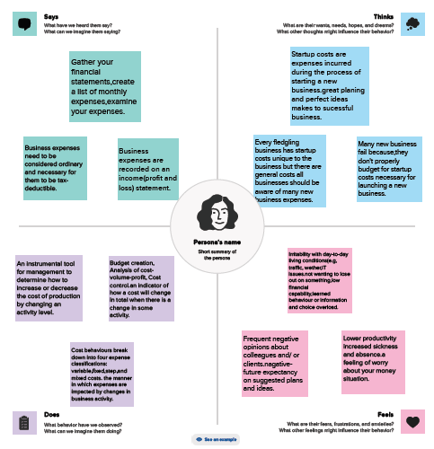

* 1. Ideation & Brainstorming Map

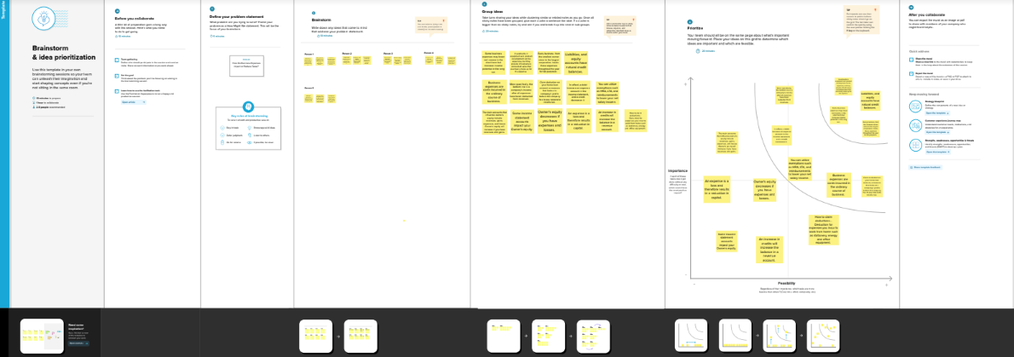

1. RESULT

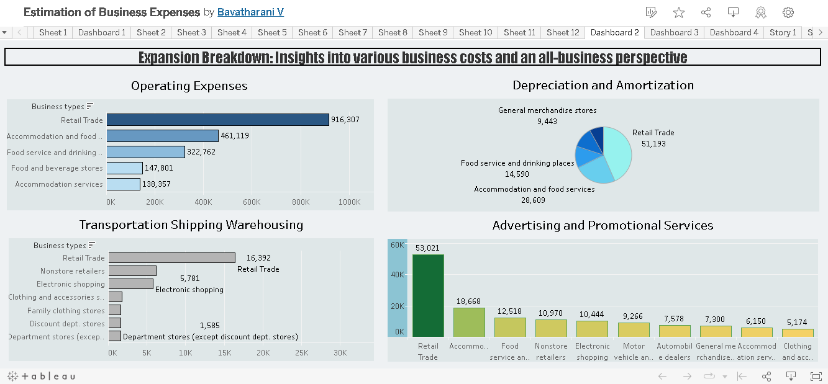

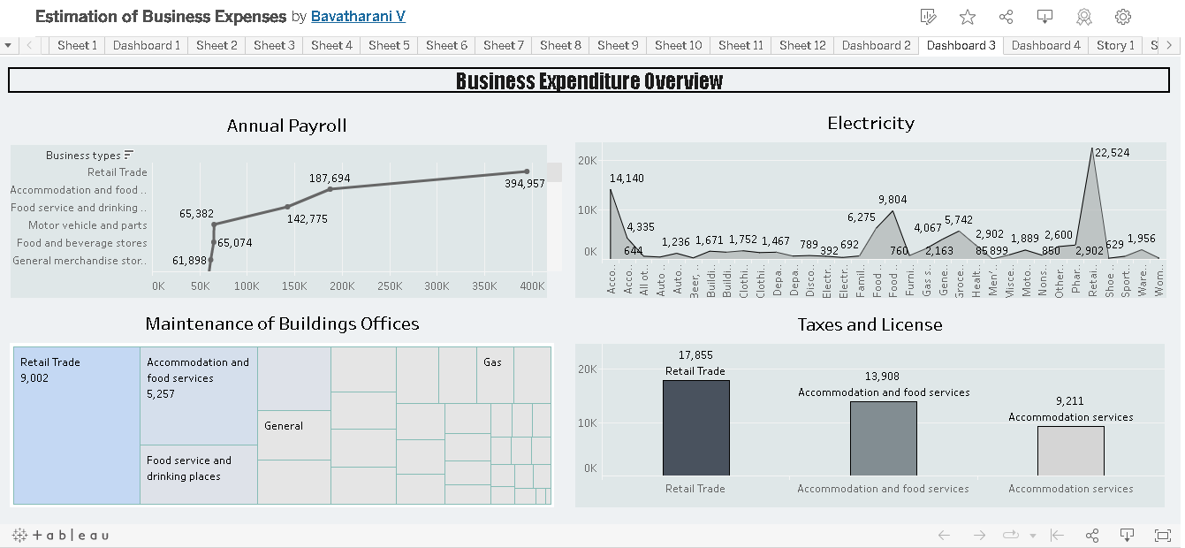

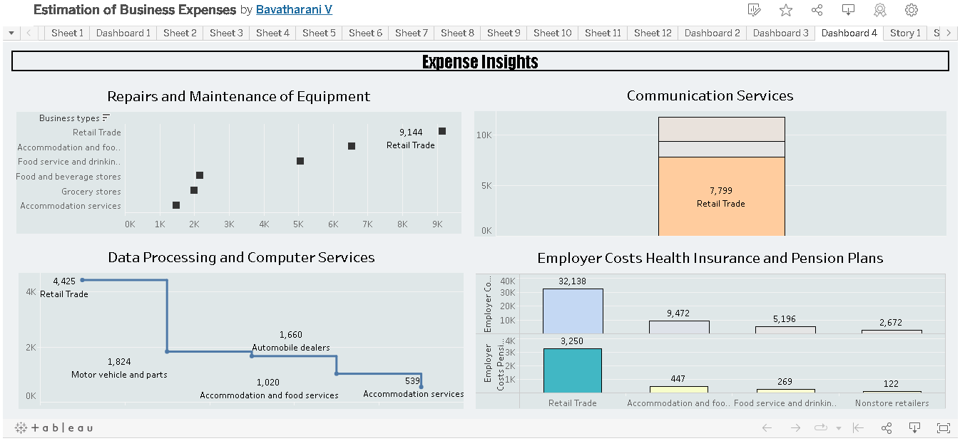

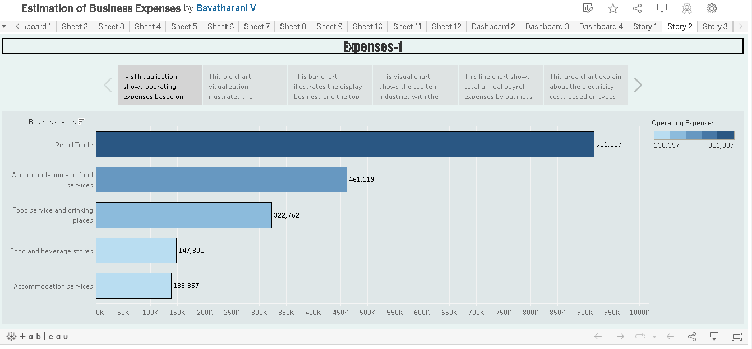

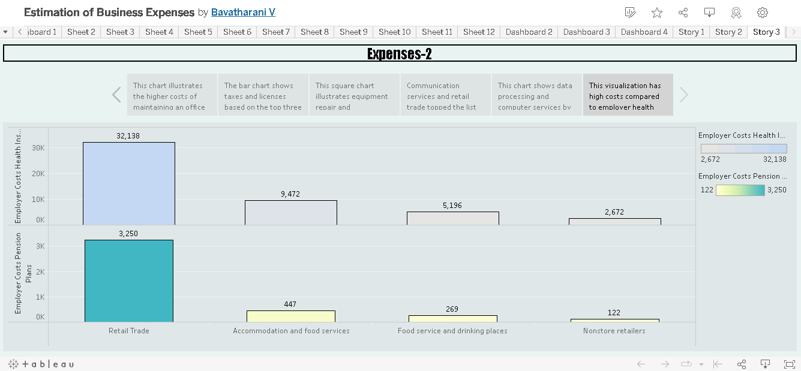

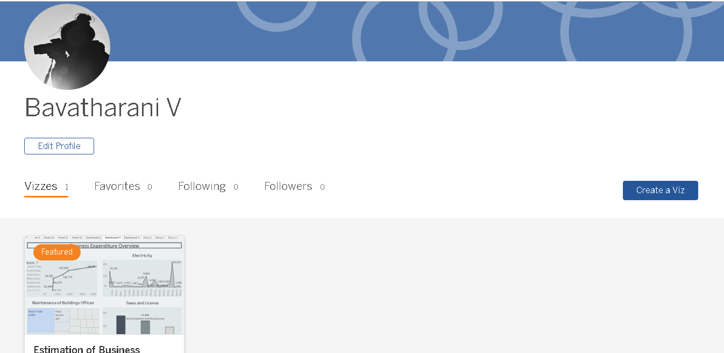

1. ADVANTAGES & DISADVANTAGES

|  |  |
| --- | --- |
| **Advantages** | **Disadvantages** |
| Helps in setting prices | Records past data |
| Identifies unnecessary costs involved | Costs keep changing every interval |
| Enhances productivity | Expertise required |
| Helps the management make effective decisions | Expensive maintenance |
| budget planning, resource allocation, risk management, improved decision-making, and competitive advantage. | Might fail to account for important financial concerns such as inflation, interest rates, varying cash flows, and the present value of money. |

1. APPLICATIONS 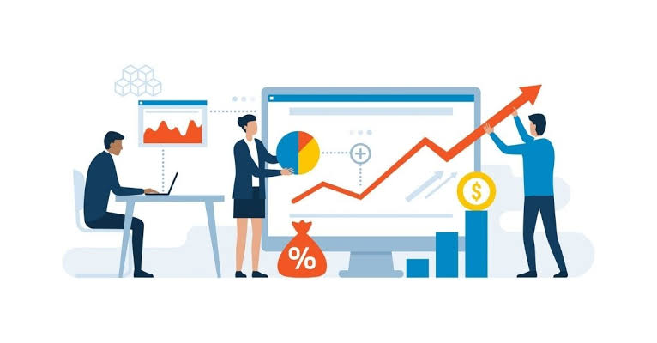

Cost accounting is helpful because it can identify where a company is spending its money, how much it earns, and where money is being lost. Cost accounting aims to report, analyze, and lead to the

Improvement of internal cost controls and efficiency.

1. CONCLUSION



As per the assessment of business expenses, this full visualization explains the expenses based on business types and retail business has the highest profit and loss.

It is at the top compared to other businesses and retail business is a smart move in this business world.

1. FUTURE SCOPE

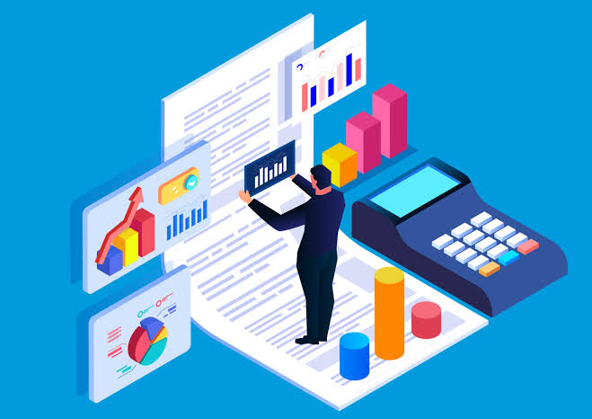

The process of forecasting the financial and other resources needed to complete a project within a defined scope.

Cutting off the unnecessary expenses, which occur during the production Process, storage, selling and distribution of the product.

Helps you map and control a budget. It lets businesses reduce costs and expenses during the year through analysis and monitoring variances at each budget control level.